Snow & Ice Policy FY 2024-2025

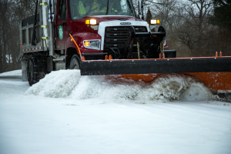

*Originally approved by Town Council on:*

*FY 2019-2020*

Contents

Legal Notices 3

General Purpose 4

Scope of Snow and Ice Removal 4

Blank Page 5

Pre Season Preparation 6

Calibration and Winter Maintenance Materials 7

Winter Maintenance Materials 7

Plow Routes and Priorities 8

Environmental Considerations and How To Calibrate 8-10

Intergovernmental Cooperation 10

Snow Fence Locations 11-14

Before The Storm

Anti-Icing Operations 15

During The Storm

Plowing 16

Deicing 16

Spreading Patterns 17

After The Storm

Clean Up 18

Storm Readiness 18

Resident Cooperation 19

Mailboxes and Property Damage 19-21

Parking 22-23

Sidewalks and Driveways 24-25

Report Unsafe Conditions and Resident Sand Supply 26

Continuous Process Improvement 27

Current Plow Routes 28 - 53

# Legal Notices

This document is intended to provide general guidelines for the Town of New Milford, CT Public Works Department. These guidelines are advisory in nature and should not be understood or interpreted as restricting the freedom of judgement which must be exercised by the individuals empowered to implement this policy or perform the winter maintenance obligations contained herein.

As each weather event presents different challenges, operational decisions – such as the mobilization of available crew, the extension of operating hours, and the maintenance and snow removal methods – consider weather conditions, institutional knowledge, and the availability of resources and will not strictly adhere to these guidelines.

This document is intended to improve transparency and encourage public cooperation with winter maintenance efforts pursuant to the Mayor’s duty under CT Gen Stat § 13a-107 to open a highway blocked with snow.

This document was prepared through a cooperative project agreement by Western Connecticut Council of Governments (WestCOG) as part of a snow removal operations, management, and routing project for 18 municipalities in Western Connecticut.

# General Purpose

This policy document was developed to define the responsibilities of the Town of New Milford, CT Public Works Department (“the Municipality” or “ the Town”) and the public during snow and ice control activities. The Municipality strives to provide a transportation system that provides an acceptable level of service within the limitations imposed by the natural environment. It should be recognized that winter storm events can be unpredictable and that the Municipality’s response is limited by the availability of equipment, material, and personnel resources. Through the course of the winter storm response and clean-up, it must be acknowledged that roadway, sidewalk, and bridge surfaces may still be hazardous despite the most diligent efforts and that caution should be exercised.

Several important aspects were considered during the development of policy document, including but not limited to:

* Public Safety
* Desire to maintain a safe and efficient transportation system
* Ability to deliver emergency services
* Availability of funding, resources, and equipment
* Individual storm characteristics
* Environmental impacts

This plan endeavors to responsibly balance the above considerations and provide the highest practical level of service through cooperation of municipal departments and citizens.

For the purpose of this document, the Winter Season will run from November 15 through March 15th.

## Scope of Snow & Ice Removal

The Municipality is responsible for winter maintenance on 226 miles of municipal roadway in addition to:

|  |
| --- |
| 533 Danbury Road (“Churyk Building”) |
| Boardman Bridge Parking Lot |
| Church Street & Bank Street Crossover / Parking Lot |
| Facility Maintenance, 20 Young’s Field Road |
| John J Pettibone Community Center, 1 Pickett District Road |
| Patriots Way Parking Lot |
| Police Department Parking Lot |
| Picket District Road Commercial Parking Lot |
| Public Works Complex, 6 Young’s Field Road |
| Public Works Material Yard/Public Works Pipe yard |
| Railroad Street Parking Lot |
| New Milford Ambulance 2 Scovill St |
| The Maxx, 94 Railroad St |

The municipality is not responsible for snow and ice control on:

|  |
| --- |
| Private Driveways |
| Private Parking Lots |
| Private Roads |
| Private Sidewalks |
| State Routes within Municipal Boundaries |

Page Empty

# Pre-Season Preperations

As snow and ice control operations are normally carried out under emergency conditions, it is necessary to undertake proper advanced preparation including obtaining the appropriate snow and ice control materials, equipment, and training. The following activities are conducted prior to the winter season to ensure efficient and effective snow and ice removal operations.

* Solicit bids and acquire contracts for trucks, equipment, salt, treated salt, sand, tire chains, snowplows parts, truck parts, solid and liquid application equipment, meteorological and other contractual services.
* Inspect equipment to ensure proper working order. Schedule and complete any and all equipment repairs.
* Contact vendors to arrange delivery for salt, sand, liquid deicers, snowplow blades, and tire chains, etc.
* Mix salt/sand, fill storage facility with salt and storage tank with liquid deicers.
* Confirm that markers for guiderails, catch basins, utility boxes, fire hydrants, and push back areas located in cul-de-sacs and intersections are in place. Ensure that steep hills and sharp curve ahead warning signs are in place. Any missing markers or signs should be replaced immediately.

**One month prior to the winter season:**

* Assign staff to the equipment.
* Assign staff to plow routes.
* Calibrate material application equipment.
* Allow staff time to familiarize themselves with any new equipment, material application rates, and material application equipment.
* Allow staff to familiarize themselves with their route noting intersections, grade changes, obstacles, tree branches and various other issues that could impact snow and ice removal efforts.
* Arrange the rental of a temporary office trailer to be used as a rest area during storms.
* Have 80% of the fleet ready to respond to a winter event.
* Have sufficient staff available to operate the fleet should conditions warrant a winter event response.
* Contact property owners adjacent to proposed snow fence area and get installation permission.
* Review winter storm event emergency contact procedures with the Police Department.

**Two weeks prior to the winter season:**

* Have 95% of the fleet ready to respond to a winter event.
* Have all staff available to operate the fleet should conditions warrant a winter event response.
* Install snow fences as arranged with property owners.
* Set up resident salt sand bin, located by the fueling station.
* Review any route changes with the affected staff.

**At the start of the winter season:**

* Have 100% of the fleet ready to respond to a winter event.
* Have all staff available to operate the fleet should conditions warrant a winter event response.
* Respond to winter events as per the winter operations plan.

## Calibration

It is important that municipal spreading equipment is calibrated regularly. Calibration helps ensure that the correct amount of material is applied to the roadway for the given weather conditions. Calibration is performed annually in accordance with manufacturers’ specifications, and/or using best practices as appropriate.

## Winter Maintenance Materials

Suitable quantities of materials will be procured and stored in preparation for use for snow and ice control operations. The Municipality, prior to the winter season, and in compliance with municipal procurement practices, shall enter into a contract, or contracts to obtain the necessary winter maintenance materials for the season. When selecting a material vendor, consideration is given to price, availability, past performance, and product quality. The Municipality will store material in a manner consistent with all applicable standards and regulations. Limited storage area may necessitate additional material procurement and delivery throughout the winter season. While every effort is made to predict the appropriate budget for required material and staffing, it is impossible to achieve this goal every season. Variability of the number, and intensity of winter storms in any given season may require additional material, resources, and funding be requested on an emergency basis. A summary of the materials procured for the winter season is provided below. Actual quantities and types of materials purchased shall be at the discretion of the Highway Foreman.

**Rock Salt:** The Municipality annually procures approximately 1,000 tons of rock salt (Sodium Chloride). Rock salt is used to weaken the bond between the snow or ice and the pavement so that it can be mechanically removed by municipal plows and other equipment. The effectiveness of rock salt varies with pavement temperatures and the Municipality may increase application rates as the pavement temperatures decreases. Rock salt also becomes dramatically less effective below surface temperatures of 15°F. Under these conditions, its use may be suspended in favor of alternative chemicals with lower operating temperatures or the application of winter sand.

The Municipality may also elect to pretreat the dry rock salt with salt brine. This “pre-treating” of the dry salt improves the effectiveness of the salt by accelerating the melting process. It also serves to reduce the bounce and scatter of the salt as it is applied, reducing the amount of material that ends up off the road surface.

**Treated Rock Salt:** The Municipality annually procures approximately 5,000 tons of treated rock salt (Sodium Chloride). The salt is treated with magnesium chloride or other suitable anti icing agent. Treated rock salt is used to weaken the bond between the snow or ice and the pavement so that it can be mechanically removed by municipal plows and other equipment. The effectiveness of rock salt varies with pavement temperatures and the Municipality may increase application rates as the pavement temperatures decreases. Treated rock salt is more effectively than regular rock salt at temperatures below 15°F.

**Winter Sand:** The Municipality annually procures approximately 1,000 tons of winter sand. This sand has been blended with rock salt to prevent it from becoming frozen in the pile. Winter sand is typically used for gravel roads, traction at dangerous intersections and when surface temperatures are too low for regular rock salt to be effective. The winter sand/salt mix may be sprayed with salt brine to increase its effectiveness in icy conditions.

**Ice Chip:** 100% biodegradable ice melt made form pulverized wood chips and other all-natural ingredients.

**Liquid Chemicals:** The Municipality now produces its own salt brine used to pretreat town roads.

## Plow Routes & Priorities

The Municipality’s roadways are categorized as arterial, collector, school/hospital/emergency routes, and residential roads with priority given to the first three categories to ensure that emergency services have adequate access. In extenuating circumstances, the Municipality may divert resources to clear specific surfaces on-demand to provide access to emergency vehicles.

Municipal plow routes are reviewed on a regular basis in advance of winter season. An overview of the current plow routes are provided on pages 28 through 53.

## Environmental Considerations

Throughout the Northeast and other “Snowbelt states”, negative environmental impacts have been increasingly observed and attributed to the use of deicing chemicals. The use of chloride-based deicing chemicals, particularly Sodium Chloride (rock salt) and Calcium Chloride, have led to groundwater contaminations in some watersheds.

Recently, the Health Department reported that an artesian well located at 1 Rabbit Lane and 127 Washington Ridge have been contaminated by road salt; these locations are restricted from deicing materials until conditions improve.

Under the Federal and State water quality standards following the Federal Water Pollution Control Act (also known as the “Clean Water Act” or CWA), the Environmental Protection Agency (EPA) considers chloride to be a regulated contaminate. In the northeast, Chloride contamination of groundwater are primarily caused by the application of deicing chemicals on impervious surfaces, such as roadways. While chloride is primarily an aesthetic concern in drinking water it is toxic to plant and animal life, even in small concentrations. In addition to water quality concerns, chloride-based deicing chemicals are a significant municipal operational expense and their efficient usage has positive impacts on municipal budgets.

In recognition of the environmental and fiscal impacts of chloride, the Municipality has undertaken the following efforts to reduce chloride imports into local groundwater. Salt reduction amounts are estimated based on industry standards. Actual salt reduction amounts are difficult to quantify due to the variability of winter weather and the circumstances of each winter storm event and season.

* **Winter Maintenance Training:** Municipal winter maintenance professionals have taken training in winter operations including appropriate applications rates, use of alternative chemicals, and calibration. The best practices for deicing application include spreading more material when the pavement temperature is colder, and less when it is warmer. Winter maintenance training ensures municipal staff are aware of current industry best practices and are equipped to efficiently and effectively perform winter maintenance operations. The staff also receives training for:
  + Storage and handling of de-icing chemicals.
  + Identification of vulnerable de-icing areas.
  + Defensive driving.
  + Record keeping.
  + Public Works policies and procedures.
  + Equipment pre-trip and post-trip inspections.
  + Personal health and safety.
  + Identification of plow routes – including variations for year to year and issues identified along the route.
  + Equipment maintenance procedures.
  + Proper use of a two-way radio.
  + Accident reporting procedures.
* **Equipment Calibration:** Calibration of spreading equipment ensures that the appropriate target amount of material is dispense onto the pavement surface. Appropriate application rates are determined using pavement temperature and weather conditions. *Equipment calibration can result in salt reduction between 5-30%*.
* **Spreader Calibration Procedure:** Calibration of spreaders is simply calculating the pounds per mile actually discharged at various spreader control settings and truck speeds. It is carried out by first counting the number of auger or conveyor shaft revolutions per minute, measuring the salt discharged in one revolution, then multiplying the two and finally multiplying the discharge rate by the minutes it takes to travel one mile. An excellent example of a calibration chart can be found on the Salt Institute website. A sample calibration chart can be found on the following page.

With hopper-type spreaders, specific gate openings must be calibrated. Measure from the floor of the conveyor to the bottom edge of the gate. Each spreader must be calibrated individually; even the same models can vary widely at the same setting.

Equipment needed:

1. Scale for weighing.
2. Canvas or bucket/collection device.
3. Chalk, crayon or other marker.
4. Watch with a second hand or stop watch.

Calibration steps:

1. Warm the truck’s hydraulic oil to normal operating temperature with the spreader system running.
2. Put a partial load of salt on the truck.
3. Mark the shaft end of the auger or conveyor.
4. Dump salt on the auger or conveyor.
5. Rev the truck’s engine to operating RPM (at least 2,000 RMP).
6. Count the number of shaft revolutions per minute at each spreader control setting and record.
7. Collect the salt for one revolution and weigh it, deducting the weight of the container. (For greater accuracy, collect the salt for several revolutions and divide by this number of turns to get the weight for one revolution.) This can be accomplished at idle or very low engine RPM. Multiply shaft RPM (Column A) by the discharge per revolution (Column B) to get the discharge rate in pounds per minute (Column C), then multiply the discharge rate by the minutes to travel one mile at various truck speeds to get pounds of discharge per mile.

* **Groundspeed Oriented Spreaders:** Groundspeed oriented spreaders control the amount of salt that is dispensed based on the vehicle speed. As the vehicle speed increases the amount of salt that is dispensed increases to maintain a consistent application rate. Likewise, when the vehicle is stopped the spreader is automatically shut off. *Groundspeed oriented spreaders can result in salt reduction of 10-15%.*

Calibrating with Automatic Controls:

Automatic controls come with factory calibration cards that indicate the proper rate of spread for each setting. However, when there is a need to calibrate, use the following steps:

1. Remove or turn of the spinner.
2. Set the auger on a given number, such as No. 2.
3. Tie a sack or heavy canvas under the discharge chute.
4. Mark a specific distance, such as 100 or 1,000 ft.
5. Drive that distance with the spreader operating.
6. Multiply the weight of the salt by 5.3 (in case of 1,000 ft.) or 52.8 (in case of 100 ft.).

This will be the amount of salt discharged per mile, which remains constant regardless of speed, but the calibration must be done for each control setting.

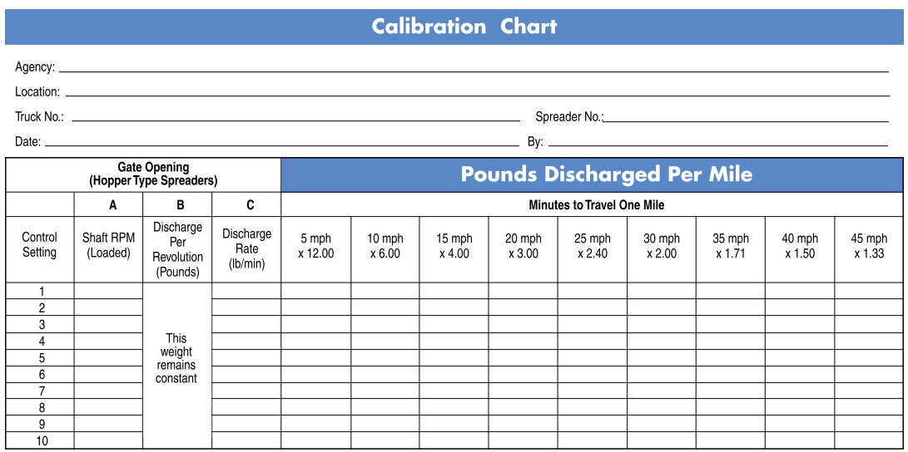

* **Anti-Icing:** Anti-icing is the proactive application of deicing chemical in advance of a storm to prevent snow and ice from bonding to pavement surfaces. Anti-icing improves the mechanical removal of snow and ice from the pavement and reduces the amount of deicing chemicals required. *Anti-Icing can result in salt reduction of roughly 10%.*
* **Pre-treated Salt:** Utilizing salt that is pre-treated with liquid chemical deicer increases its effectiveness. The liquid on the solid salt reduces bounce and scatter and keeps the deicer on the pavement. Pre-treated salt also more rapidly begins to melt and loosen snow and ice so it can be removed with plows and other equipment. *Pre-treated salt can result in salt reductions of 10-15%.*
* **Ice Chip:** The town will be utilizing a new 100% biodegradable ice melt made from all natural ingredients. First applications will be on gravel roads and if successful, will be used on paved roads.

It is important to note that research has indicated that sand is not an environmentally-friendly alternative to salt. The application of sand leads to issues with air quality (due to dust), the clogging of municipal storm water infrastructure, and increased sedimentation of surface waters which leads to increased water temperature and bacterial growth.

## Intergovernmental Cooperation

During winter storm events, public safety is significantly impacted by the removal of snow and ice from roadways and other surfaces. This policy encourages cooperation between all applicable municipal departments including Public Works, Police, Parks and Recreation, Fire, and Schools. All municipal departments are committed to working together to strive for a safe transportation network.

As part of maintaining a combined state and local road network during storm events, the Municipality may assist the State of Connecticut Department of Transportation (CTDOT). This may include treating hazardous areas, and/or sharing materials in emergencies.

The Town has participated in a regional routing study with its neighboring communities, to document existing practices, develop local best management practices, and optimize plow routes. In this manner, the community seeks to be regionally responsible and provide assistance and mutual aid to neighboring communities during emergencies.

## SNOW FENCE LOCATIONS

Prior to the winter season, the Municipality installs snow fences in strategic locations to minimize snow from drifting across Ridge Road and Creamery Road, Ridge Road and Hartwell Road, Hartwell Road and Chapin Road.

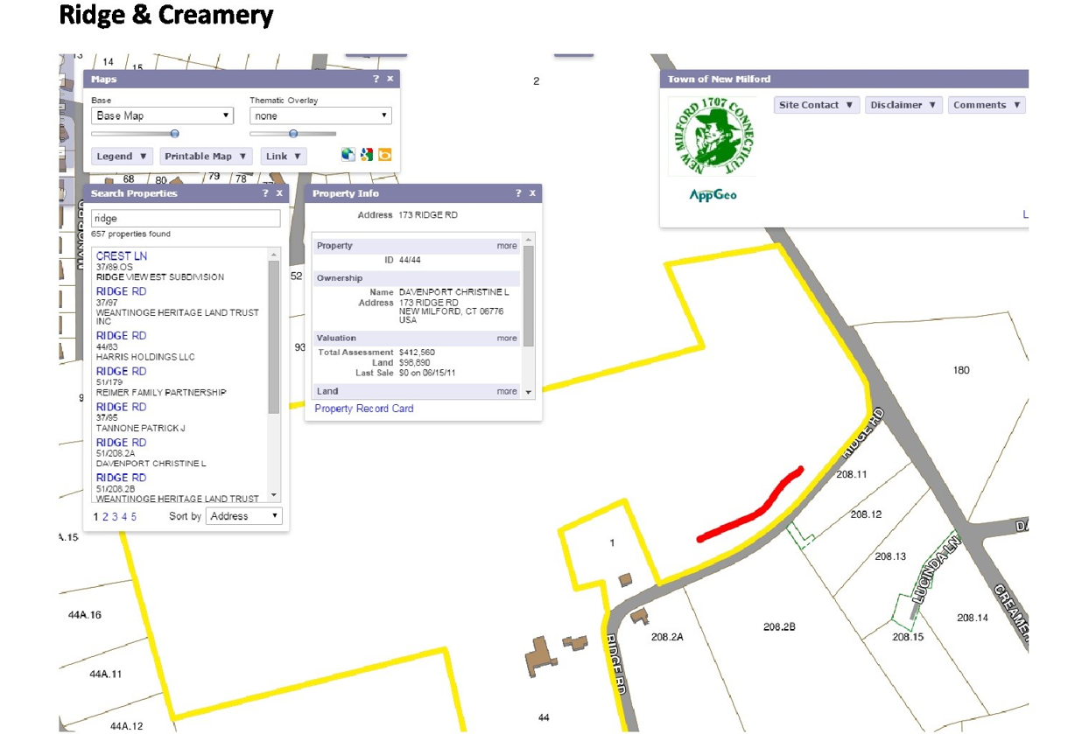

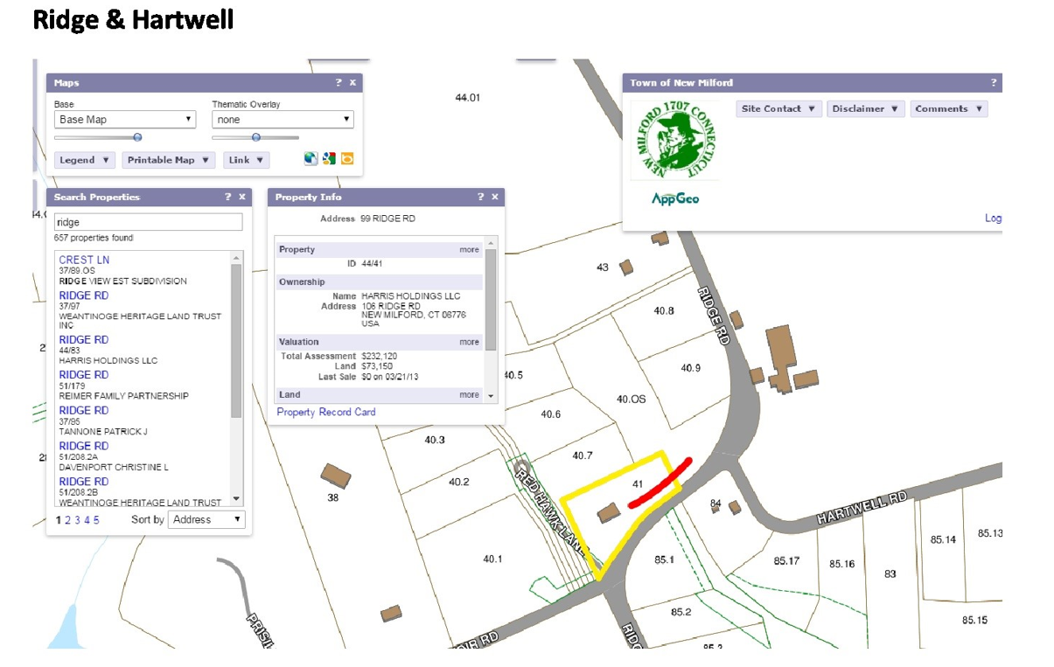

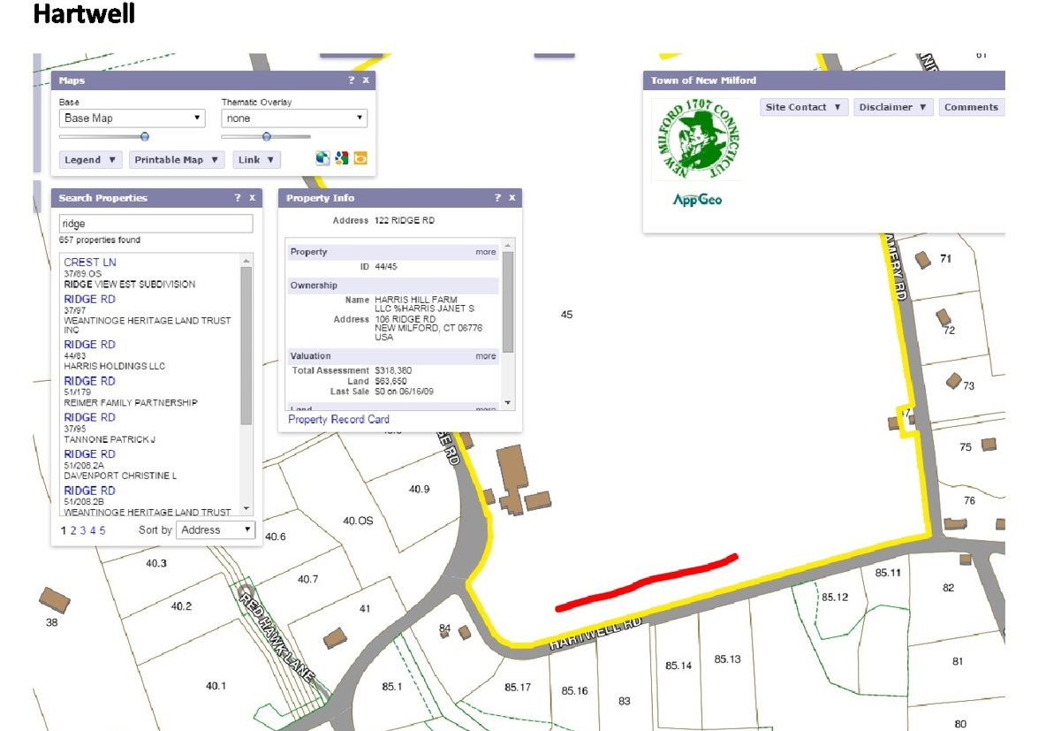

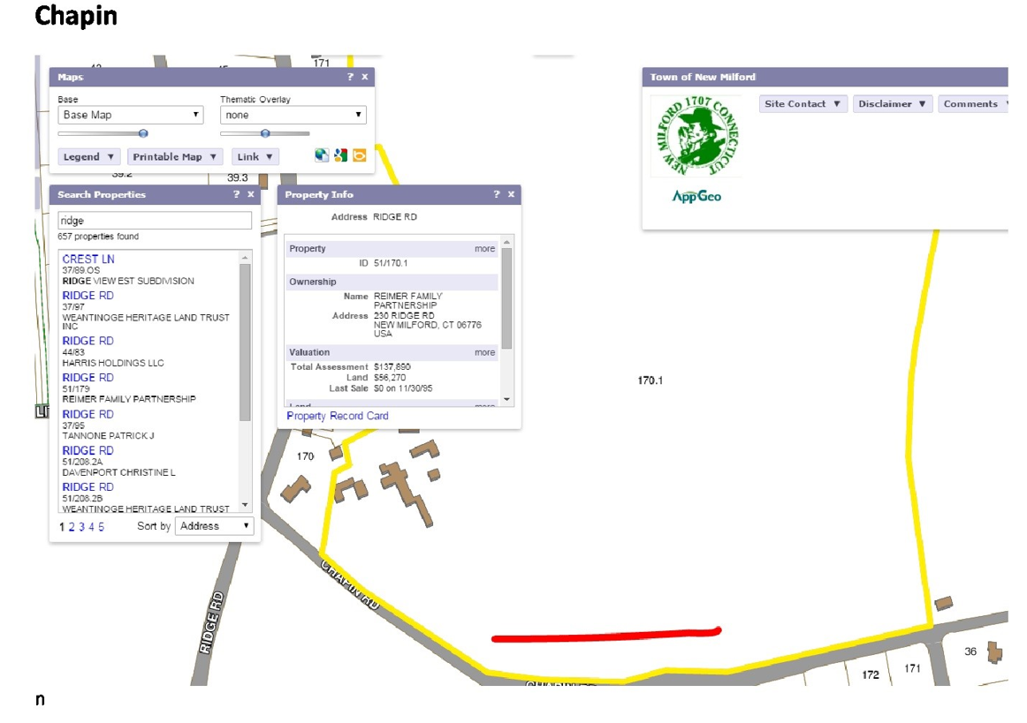

# Before the Storm

## Anti-Icing Operations

Anti-icing is the proactive application of deicing chemicals in advance of a storm to prevent snow and ice from bonding to pavement. Anti-icing allows more snow and ice to be mechanically removed from the pavement surface and decreases the amount of deicing chemical that is needed to clear the roadways.

Anti-icing may take place up to 48 hours in advance of a storm. The Town will be utilizing a salt brine mixture made with straight Rock Salt and water to pretreat. This material will be produced at the Public Works Facility.

Residents will notice wet strips, then white dusty strips on the roadways in advance of storms during which anti-icing is appropriate. Anti-Icing is most typically utilized between the 15-35⁰F. Anti-icing operations may be restricted to hills and priority roadways based on available resources and storm conditions.

The Town may also elect to apply solid anti-icing chemicals under certain circumstances (e.g. freezing rain or mixed precipitation events) Anti-icing with solid deicing chemicals is generally utilized closer to the start of the storm.

# During the Storm

During the storm, the Municipality acknowledges that it is not possible to maintain completely snow-and-ice-free roadways. It is the intention of the Municipality to provide the safest transportation conditions practical and return roadways to bare pavement as soon as is possible after the storm. The Municipality engages in the following snow and ice control operations in response to winter storm events and at the discretion of the Highway Foreman. The actual schedule of winter operations will be storm-and-resource-dependent and at the discretion of the Highway Foreman.

## Plowing

Mechanical removal of snow and ice is the most efficient and effective method to clear roadways, parking lots, and sidewalks. Snow plow operations begin at the discretion of the Highway Foreman, typically after accumulations of one inch. Plow operations continue as needed throughout the duration of the storm. Priority is given to arterial and collector roadways, followed by school/emergency/evacuation routes, and finally residential roadways.

During larger storms, the focus of plow operations is to ensure that roadways are passable. This may result in the full width of pavement not being cleared until after initial operations have completed. Plow operations continue after deicing operations have commenced with the goal of removing snow and ice that has been loosened by the deicing chemicals. Plow operations may be suspended or curtailed for a period of time (typically around midnight) to allow municipal crews time to rest in accordance with applicable state and federal requirements. Plowing may also be stopped during times of mixed precipitation (sleet or freezing rain) during or after a snowfall as plowing may result in a more slippery road condition.

## Deicing

The Municipality utilizes the deicing chemicals described in the Winter Maintenance Materials section of this document to loosen the bond between the snow and ice and the pavement. It is not economically feasible or environmentally friendly to attempt to melt all snow and ice; these chemicals serve to increase the efficiency of mechanical removal by plows and other equipment.

The Municipality utilizes salt sand for its gravel roads. The use of salt and sand on paved surfaces is a discretionary decision that is dependent on many factors including the weather and roadway conditions, the anticipated changes in these conditions, and operational constraints of the Municipality’s Public Works Department. Decisions also depend on anticipated traffic loads, the timing and duration of the storm event, and the forecasted temperature changes. All of these contributing factors are evaluated prior to the selection of materials and methods.

Deicing operations commence at the discretion of the Highway Foreman. Chemical application rates are guided by both weather conditions and applicable industry standards. Generally, application rates will vary between [150 lb/lane mile and 500 lb/lane mile] with the higher application rates being reserved for lower temperatures or mixed precipitation events (freezing rain or sleet). Application rates are adjusted as necessary for road and weather conditions by municipal staff and may not match the specific rates presented in this policy.

It should be noted that the effectiveness of dry rock salt is significantly reduced at pavement temperatures below 15⁰F. For this reason, the Municipality may suspend traditional deicing operations due to low pavement temperatures. During these low temperature events, winter sand (a mixture of sodium chloride and sand) may be applied to provide traction until the temperature increases enough to continue deicing operations.

## SPREADING PATTERNS

Salt is generally applied to the middle 1/3 of the pavement and on high side of super-elevated curves. Spread width may be increased or decreased at the discretion of the individual applying the material and depending upon the action of traffic. Timing of the initial application during each storm is very important. Generally, spreading should be delayed until there is sufficient accumulation on the pavement to hold and contain the material. However, each storm event is unique and the decision regarding the timing of the application is left to the discretion of the individuals charged with the responsibility for implementing the winter maintenance policy.

Portions of the road network are unique due to various physical conditions and will require a greater application rate or an additional application during some storms. However, these areas should be judged and treated separately and not used to evaluate and subsequently direct complete applications over the entire network. Periodic observation of pavement conditions is recommended to ensure that operations are being performed efficiently.

When possible, and at the discretion of the individual responsible for performing the task, the width of material spread (throw plus roll) may be restricted to increase the concentration of the deicing material where it is needed and therefore increase the effectiveness of the application. Spreading operations should be conducted at lower speeds. Air turbulence created by the spreader vehicle at higher speeds makes it difficult to retain the material discharged within the desired width. Applicator speeds (e.g. belt and/or spinner) and spread pattern may be adjusted to obtain the correct spread rate and to retain the material within the required width.

# After The Storm

## Cleanup

Following a winter storm event, there are many necessary clean-up activities that may be undertaken by the Municipality. The timing of these activities will be at the discretion of the Highway Foreman and may not commence immediately after the storm event. There is a preference for storm clean-up to take place during daylight hours outside of peak travel periods.

These activities may include:

* Pushing snow to the curb or ditch line to make the full width of pavement passable.
* Clearing of culverts and residential (non-private) roadways.
* Clearing or widening of intersections to increase line-of-site.
* Spot treatment of icy or dangerous areas.
* Snow removal or relocation.
* Additional deicing treatments.

## Storm Readiness

At an appropriate time following the completion of winter maintenance obligations, additional activities may take place to ensure readiness for subsequent winter operations.

These activities may include:

* Equipment inspection, repair, and preventative maintenance including cleaning of all salt spreader equipment and vehicles.
* Replenishing and/or stockpiling of materials (e.g. deicing chemicals).
* Depending upon available resources, and at the discretion of the individuals implementing this policy plow routes may be checked for problems.
* Depending upon available resources, and at the discretion of the individuals implementing this policy, roadside snow may be pushed back further off the road.
* Depending upon available resources, and at the discretion of the individuals implementing this policy the height of snow banks may be decreased, and/or snow removed from problem areas.

# Resident Cooperation

Residents can assist municipal crews through the course of the winter storm events and cleanup efforts. Please consider the following ways residents can assist, if you are able and can do so safely.

* **Clear snow from sidewalks as soon as possible.** Clearing sidewalks quickly can prevent snow from turning into a hazard for pedestrians, which may force them to walk in the roadway. Sidewalks must be clear within 24 hours after the storm.
* **Do not place snow removed from driveways or sidewalks onto the street.** When removing snow, especially with equipment such as snow blowers, direct the stream of snow and debris away from the street. This material can strike and cause damage to passing vehicles and lead to accidents. Snow that is thrown into the street will also be pushed back into the driveway by passing plows. When removing snow from driveways it can also be helpful to pile it to the right of the driveway to reduce the amount of snow re-plowed into the driveway.
* **Clear snow from around mailboxes.** Clearing snow from your mailbox will keep mail delivery vehicles from blocking traffic and help prevent accidents. It may also help prevent damage to the mailboxes from passing plows as the mailbox will be visible and there will be adequate space for accumulated snow that is pushed out of the roadway by the plow.
* **Clear snow from around fire hydrants.** Keeping hydrants clear can save firefighters and other emergency personnel critical time when responding to emergencies. This can save both lives and property.

## Mailboxes & Property Damage

The Municipality assumes no liability for damage to private property that is located within the public right-of-way.

Mailboxes and supporting posts must be properly installed to withstand the rigors of the winter season including the force of snow pushed from the roadway. The Municipality’s updated mailbox replacement policy is provided on pages 20 and 21.

Other property which is damaged as a result of snow and ice control operations will be evaluated on a case-by-case basis.

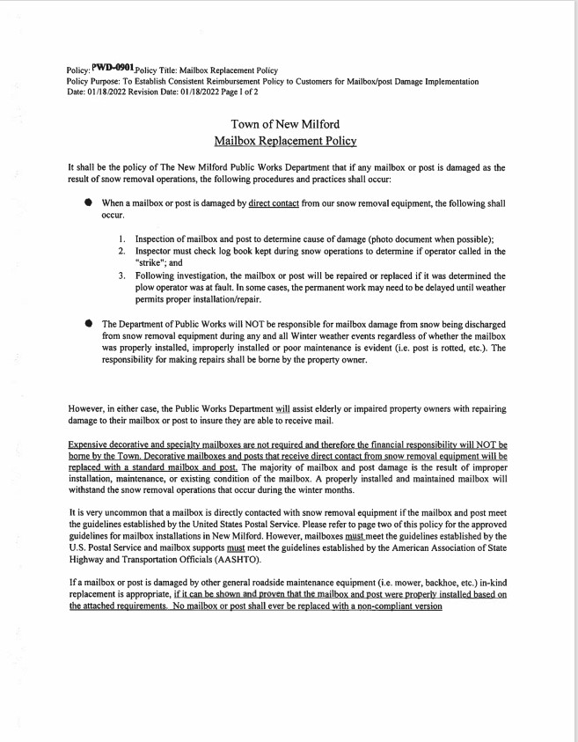

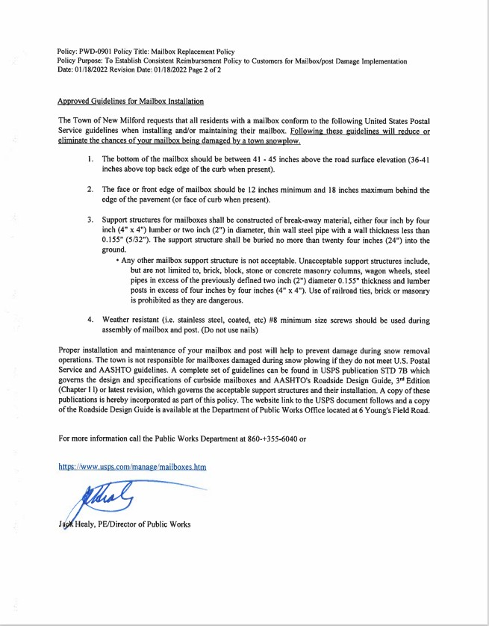

## Parking

**Chapter 18: Streets and Sidewalks**

**ARTICLE I: Snow Emergencies** [§ 18-1**Definitions.**](https://ecode360.com/13616955#13616956)

[Ord. of 11-21-2006]

As used in this article the following terms shall has the meanings indicated:

[***Owner***](https://ecode360.com/13616957#13616957)

means the owner, registrant or lessee in of a motor vehicle as defined in Connecticut General Statutes Section 14-1(51).

[***Snow emergency***](https://ecode360.com/13616958#13616958)

means any snowfall or ice event that is expected, is in progress or has occurred that will require road plowing, sanding, salting and/or snow and ice removal (hereinafter referred to as "treatment") and has been declared to be a snow emergency.

[***Snow emergency route***](https://ecode360.com/13616959#13616959)

means a town road that has been designated a snow emergency route and has been identified as such by signage.

[§ 18-2**Authority to declare snow emergency; parking prohibited.**](https://ecode360.com/13616955#13616960)

[Ord. of 11-21-2006]

The Public Works Director (hereinafter the "Director") with the approval of the Mayor, shall have the authority to declare a snow emergency when the Director has determined that public health and safety requires the temporary suspension of street parking on snow emergency routes so as to facilitate treatment of such roads. Parking shall be prohibited on snow emergency routes during a snow emergency. Any motor vehicle parked on a snow emergency route during a snow emergency may be considered an obstruction to traffic and hindrance to road treatment and a threat to public health and safety.

[§ 18-3**Declaration; notice.**](https://ecode360.com/13616955#13616961)

[Ord. of 11-21-2006]

When practicable, declaration of a snow emergency shall be made at least three hours before the effective time of the snow emergency. The Director shall notify the Chief of Police of such declaration and shall request local radio and television stations to broadcast the declaration and announce that parking on snow emergency routes is prohibited during the snow emergency. Each snow emergency route shall be identified by road signs approved by the New Milford Traffic Authority.

[§ 18-4**Duration.**](https://ecode360.com/13616955#13616962)

[Ord. of 11-21-2006]

A snow emergency shall remain in effect until rescinded by the Mayor in consultation with the Director.

[§ 18-5**Establishment; signs and markings.**](https://ecode360.com/13616955#13616963)

[Ord. of 11-21-2006]

Snow emergency routes shall be designated (and may be added and deleted as such) by the Mayor in consultation with the Director, who shall prepare and maintain a list of such designated roads. Notice of snow emergency routes shall be published in a newspaper of general circulation within the Town and provided to the Chief of Police and the Traffic Authority. The Director, following approval of signage by the Traffic Authority, shall cause signs and markings to be installed on snow emergency routes identifying them as such. Such signs shall also state that vehicles parked on a snow emergency route during a snow emergency will be removed and stored at the vehicle owner's expense.

[§ 18-6**Violation defined; notice of violation; fine; vehicle removal.**](https://ecode360.com/13616955#13616964)

[Ord. of 11-21-2006]

The owner of any motor vehicle parked on a snow emergency route during a declared snow emergency shall be in violation of this article. A police officer discovering such vehicle may issue a notice of violation in accordance with the provisions and procedures set forth in Code of New Milford Chapter [**20**](https://ecode360.com/13594477#13594477). The owner of the vehicle shall be fined $100 for each violation. Additionally, if a police officer determines that a motor vehicle parked in violation of this article is an obstruction to traffic, hindrance to road treatment or a threat to public health and safety, the officer may order such motor vehicle taken to and stored at a suitable place at the expense of the owner pursuant to the provisions of Code of New Milford § [**20-6**](https://ecode360.com/13594521#13594521) and Connecticut General Statutes Section 14-150.

[§ 18-7**Payment of fines and expenses of removal and storage; hearing.**](https://ecode360.com/13616955#13616965)

[Ord. of 11-21-2006]

An owner to whom a notice of violation has been issued shall pay the fine or request a hearing to contest the claimed violation within 10 days of the issuance of the notice. Removed and stored vehicles shall be disposed of and expenses satisfied in accordance with Connecticut General Statutes Section 14-150. In the event a vehicle owner wishes to contest a notice of violation and/or removal authority, a hearing and disposition following hearing, including collection of fines and vehicle removal and storage expenses shall be provided for and conducted in accordance with Code of New Milford Section [**20-5**](https://ecode360.com/13594506#13594506) and Connecticut General Statutes Section 14-150.

[§ 18-8**Appeal.**](https://ecode360.com/13616955#13616966)

[Ord. of 11-21-2006]

Any owner aggrieved by a decision of a hearing officer appointed to hear and dispose of a contested notice of violation may appeal such decision to the Superior Court for the Judicial district of Litchfield within 30 days of the issuance of the hearing officer's decision.

[§ 18-9**through § 18-22. (Reserved)**](https://ecode360.com/13616955#13616967)

## Sidewalks

**Chapter 18: Streets and Sidewalks**

**ARTICLE III. Sidewalks, Curbs and Gutters**

**DIVISION 1. Maintenance**

[§ 18-39 **Definitions.**](https://ecode360.com/13617117#13617103)

[Ord. of 3-28-1969, § 1; Ord. of 5-25-1973, § 1]

The following words shall, unless the context requires otherwise, be construed and understood as follows:

[***Sidewalk***](https://ecode360.com/13617104#13617104)

shall mean any portion of the street, usually lying on either side thereof, between the curb and the adjacent property line, intended for the use of pedestrians.

[***Street***](https://ecode360.com/13617105#13617105)

shall mean and include avenues, highways, roads, alleys, lanes, bridges and the approaches thereto, and all other public thoroughfares in the town, and shall also mean all that part thereof from property line to property line of the premises abutting thereon.

[§ 18-40**Removal of snow by abutting owners.**](https://ecode360.com/13617117#13617106)

[Ord. of 3-28-1969, § 2; Ord. of 5-25-1973, § 2]

Any fall of snow or sleet upon any sidewalk in the town, or any ice upon such sidewalks, shall be cleared or caused to be cleared by the owner of land, building or premises adjoining or fronting upon such sidewalk or connected therewith.

[§ 18-41**Time limit for removal of snow and ice.**](https://ecode360.com/13617117#13617107)

[Ord. of 3-28-1969, § 3; Ord. of 5-25-1973, § 3]

The clearance of snow, sleet or ice, as provided for in § [**18-40**](https://ecode360.com/13617106#13617106), shall be made within 24 hours following the cessation of the fall of snow, sleet or rain.

[§ 18-42**Unremovable portion to be made safe.**](https://ecode360.com/13617117#13617108)

[Ord. of 3-28-1969, § 4]

If snow, sleet or ice cannot be wholly cleared, as provided in § [**18-40**](https://ecode360.com/13617106#13617106), the owner shall clear so much thereof as is reasonably possible and provide a passageway for the passage of pedestrians, and sprinkle sufficient sand, ashes, sawdust or other proper substance in such quantity over the passageway and keep the same in a safe condition for public travel at all times.

[§ 18-43**Clearing of sidewalks by town; collection of costs.**](https://ecode360.com/13617117#13617109)

[Ord. of 3-28-1969, §§ 6, 7]

[**(a)**](https://ecode360.com/13617110#13617110)In addition to any other penalty provided by law, if any owner or occupant fails to comply with the provisions of §§ [**18-40**](https://ecode360.com/13617106#13617106) and [**18-42**](https://ecode360.com/13617108#13617108), the Highway Department and its employees may clear snow and ice from such sidewalks. The expense of such clearing shall be a lien upon the premises adjoining and abutting on such sidewalks and the Board of Selectmen may cause a certificate of lien therefor to be recorded in the Town Clerk's office within 60 days after such clearing as provided by the General Statutes.

[**(b)**](https://ecode360.com/13617111#13617111)The expense of clearing snow and ice by the Highway Department as provided in Subsection [**(a)**](https://ecode360.com/13617110#13617110) of this section and the cost of the lien therefor may be entered in the next succeeding rate bill for taxes against the owner of the premises with the tax assessed upon such premises, and if the expense and the cost of the lien is paid with such taxes, the lien shall be discharged; if not so paid, the lien may be foreclosed in the manner hereinbefore provided.

[§ 18-44**Penalty for failure to clear sidewalks.**](https://ecode360.com/13617117#13617112)

[Ord. of 3-28-1969, § 5]

Any person who violates or refuses or neglects to comply with the provisions of §§ [**18-40**](https://ecode360.com/13617106#13617106) through [**18-42**](https://ecode360.com/13617108#13617108) shall be punished by a fine not exceeding $5 for each violation, and each day of failure to comply with such provisions shall constitute a separate offense.

[§ 18-45**Maintenance of sidewalks by abutting owners required.**](https://ecode360.com/13617117#13617113)

[Ord. of 3-28-1969, § 9]

Any person owning or occupying any lands in the town in front of which is a sidewalk, either paved of concrete or cement or otherwise constructed to the approval of the proper authorities of the town, shall keep such sidewalk, at all times, in safe condition and repair for the use of the public and free from obstruction and defects.

[§ 18-46**Repair of sidewalks by town; collection of costs.**](https://ecode360.com/13617117#13617114)

[Ord. of 3-28-1969, § 10]

[**(a)**](https://ecode360.com/13617115#13617115)If any sidewalk obstruction or defect or the need of repair exists, the Board of Selectmen shall notify the owner, agent or occupant of the abutting premises to remove such obstruction or defect or make such repairs and, if the same are not made within 30 days after such notice, the town may perform the same.

[**(b)**](https://ecode360.com/13617116#13617116)The expense of such repairs by the town shall be a lien upon such abutting property in favor of the town, which may be continued if a certificate thereof is filed with the Town Clerk within 60 days of the completion of such work, and the same may be collected by the town by any proper form of legal or equitable action.

[§ 18-47 **through § 18-54. (Reserved)**](https://ecode360.com/13617117#13617117)

## Driveways

The Municipality is not responsible for clearing private driveways or private driveway entrances. While clearing the roadway, municipal plows will create piles of snow in private driveways. Property owners or residents are responsible for clearing this snow. When plowing, shoveling or blowing snow from a driveway or sidewalk, no snow shall be placed within the travel portion of the roadway. Doing so creates a hazard and unsafe conditions for vehicles and pedestrians.

[**Chapter 18: Streets and Sidewalks**](https://ecode360.com/13616954)

[**ARTICLE II: Road Acceptance Requirements**](https://ecode360.com/13616968)

[§ 18-24**General regulations.**](https://ecode360.com/13616968#13616993)

[**(r)**](https://ecode360.com/13617034#13617034)Snow discharge. No person, firm or corporation shall discharge any snow from any private driveway, road or parking area upon any town highway.

## Reporting Unsafe Conditions

Residents who witness an unsafe condition beyond normal snow accumulation during a storm are encouraged to report it directly to either:

Public Works Main Number at (860) 355-6040

Michael Boucher, Highway Foreman at (860) 355-6045, ext. 3220

Christopher Jurgens, Deputy Highway Foreman at (860) 355-6045, ext. 3222

NMDPW Snow Desk at (860)-355-6045, ext 3221 (This phone only manned during Winter Storm Operations)

Issues may also be reported to <https://seeclickfix.com/new-milford> and the NMDPW will respond accordingly.

Appropriate response to the reported unsafe condition will be determined by the Public Works Department.

## Resident Sand Supply

As long as such materials are readily available, mixed sand/salt for non-commercial residential use will be available at the location below. Each resident shall be limited to two (2) five-gallon pails per visit in an effort to provide as many residents as possible the opportunity to participate in this service.

Location: 6 Youngs Field Rd, just past the Public Works facility.

# Continious Process Improvement

The Municipality is committed to continuous improvement of its snow and ice control operations. Each year, the Municipality strives to improve operations and to provide citizens with the highest quality transportation network. This is accomplished through several methods, including:

* Direct communication with municipal leadership
* Task-specific employee meetings
* Responding to resident suggestions and complaints
* Evaluating and implementing public works staff suggestions
* Transfer of best practices or successful innovations (both internal and external)
* Attending best practice training and conferences
* Participation in regional winter maintenance studies with WestCOG
* Collaborating with neighboring public works directors and the CTDOT

Prepared by Michael Boucher 2023

|  |  |  |  |  |
| --- | --- | --- | --- | --- |
| **Lehn Truck 168** | **A** | **Paved** | **Dirt** | **Road T** |
| Boardman Road |  | 1.10 | 0.00 | 1.10 |
| Cortland Drive |  | 0.64 | 0.00 | 0.64 |
| Candlewood Vista |  | 0.50 | 0.00 | 0.50 |
| Candlewood Shore |  | 0.50 | 0.00 | 0.50 |
| Bullymuck Road |  | 0.67 | 0.00 | 0.67 |
| Candlewood Mountain Road |  | 3.22 | 0.00 | 3.22 |
| Green Pond Road |  | 0.06 | 0.00 | 0.06 |
| Candlewood Common |  | 0.31 | 0.00 | 0.31 |
| Housatonic Avenue |  | 1.06 | 0.00 | 1.06 |
| Russet Lane |  | 0.13 | 0.00 | 0.13 |
| Jotham Road |  | 0.54 | 0.00 | 0.54 |
| Concord Way |  | 0.45 | 0.00 | 0.45 |
| Lookout Ridge Road |  | 0.16 | 0.00 | 0.16 |
| Meadowwood Drive |  | 0.50 | 0.00 | 0.50 |
|  |  |  |  |  |
|  |  |  |  | **9.84** |

|  |  |  |  |  |
| --- | --- | --- | --- | --- |
| **Kishonis Truck 125** | **B** | **Paved** | **Dirt** | **Road T** |
| Birch Road |  | 0.20 | 0.00 | 0.20 |
| Skyview Drive |  | 0.29 | 0.00 | 0.29 |
| Cannon Lane |  | 0.12 | 0.00 | 0.12 |
| Candlewood Lake Road N |  | 3.53 | 0.00 | 3.53 |
| Fenway Drive |  | 0.06 | 0.00 | 0.06 |
| Perry Drive |  | 1.01 | 0.00 | 1.01 |
| Fox Run |  | 0.39 | 0.00 | 0.39 |
| Tamarack Drive |  | 0.53 | 0.00 | 0.53 |
| Old Town Park Road |  | 0.74 | 0.00 | 0.74 |
| Mockingbird Lane |  | 0.16 | 0.00 | 0.16 |
| Edgewood Drive |  | 0.16 | 0.00 | 0.16 |
| Sunny Valley Lane |  | 0.45 | 0.00 | 0.45 |
| Willow Road |  | 0.20 | 0.00 | 0.20 |
| Wynwood Drive |  | 0.32 | 0.00 | 0.32 |
| Linden Lane |  | 0.11 | 0.00 | 0.11 |
| Ledge Lane |  | 0.18 | 0.00 | 0.18 |
| Lone Oak Drive |  | 0.59 | 0.00 | 0.59 |
| Willow Lane |  | 0.13 | 0.00 | 0.13 |
| Rabbit Lane |  | 0.14 | 0.00 | 0.14 |
| Jerusalem Road |  | 0.46 | 0.00 | 0.46 |
| Aspen Way |  | 0.07 | 0.00 | 0.07 |
| Hilltop View Road |  | 0.38 | 0.00 | 0.38 |
| Hilltop View Lane |  | 0.20 | 0.00 | 0.20 |
|  |  |  |  | **10.42** |

|  |  |  |  |  |
| --- | --- | --- | --- | --- |
| **Sweeney Truck 20** | **C** | **Paved** | **Dirt** | **Road T** |
| Caldwell Drive |  | 0.43 | 0.00 | 0.43 |
| Blue Bonnet Knoll |  | 0.25 | 0.00 | 0.25 |
| Dartmouth Road |  | 0.20 | 0.00 | 0.20 |
| Dodd Road |  | 0.34 | 0.00 | 0.34 |
| Town View Drive |  | 0.28 | 0.00 | 0.28 |
| Old State Road II |  | 0.26 | 0.00 | 0.26 |
| Sunny Valley Road |  | 1.56 | 0.00 | 1.56 |
| Lanesville Road |  | 0.71 | 0.00 | 0.71 |
| Pickett District Road/Parking Lot |  | 1.98 | 0.00 | 1.98 |
| Sherwood Drive |  | 0.43 | 0.00 | 0.43 |
| Old State Road I |  | 0.21 | 0.00 | 0.21 |
| Howe Road |  | 0.10 | 0.00 | 0.10 |
| Peagler Hill Road |  | 0.17 | 0.00 | 0.17 |
| Fort Hill Road |  | 0.87 | 0.00 | 0.87 |
| Maloney Lane |  | 0.10 | 0.00 | 0.10 |
| Young's Field Road |  | 0.52 | 0.00 | 0.52 |
| Tanglewood Lane |  | 0.09 | 0.00 | 0.09 |
| Sega Drive |  | 0.37 | 0.00 | 0.37 |
|  |  |  |  | 8.87 |

|  |  |  |  |  |
| --- | --- | --- | --- | --- |
| **Assheton Truck 179** | **D** | **Paved** | **Dirt** | **Road T** |
| Polaris Drive |  | 0.26 | 0.00 | 0.26 |
| Overlook Drive |  | 0.54 | 0.00 | 0.54 |
| Red Cedar Drive |  | 0.41 | 0.00 | 0.41 |
| Forest Drive |  | 0.18 | 0.00 | 0.18 |
| Gretl Lane |  | 0.23 | 0.00 | 0.23 |
| Sullivan Road/Sullivan Court |  | 0.96 | 0.00 | 0.96 |
| Dailey Road |  | 0.07 | 0.00 | 0.07 |
| Larson Road |  | 0.30 | 0.00 | 0.30 |
| Carlson Road |  | 0.27 | 0.00 | 0.27 |
| Eagle Drive |  | 0.11 | 0.00 | 0.11 |
| Carmen Hill Road II |  | 1.49 | 0.00 | 1.49 |
| Carmen Hill Road I |  | 0.92 | 0.00 | 0.92 |
| Candlewood Lake Road S |  | 2.90 | 0.00 | 2.90 |
| Mist Hill Drive |  | 0.71 | 0.00 | 0.71 |
| Old Aldrich Road |  | 0.00 | 0.21 | 0.21 |
| Warwick Drive |  | 0.31 | 0.00 | 0.31 |
| Ormsby Lane |  | 0.16 | 0.00 | 0.16 |
| Short Drive |  | 0.09 | 0.00 | 0.09 |
|  |  |  |  | **10.12** |

|  |  |  |  |  |
| --- | --- | --- | --- | --- |
| **Sweet Truck 26** | **E** | **Paved** | **Dirt** | **Road T** |
| New Bridge Road |  | 0.40 | 0.00 | 0.40 |
| Morey Road |  | 0.30 | 0.00 | 0.30 |
| McKayla Drive |  | 0.17 | 0.00 | 0.17 |
| Pumpkin Hill Road |  | 2.30 | 0.00 | 2.30 |
| Dogwood Drive |  | 0.16 | 0.00 | 0.16 |
| Wampum Drive |  | 0.20 | 0.00 | 0.20 |
| June Rd |  | 0.33 | 0.00 | 0.33 |
| BoxwoodLane |  | 0.50 | 0.00 | 0.50 |
| Erickson Road |  | 1.38 | 0.00 | 1.38 |
| Cross Road |  | 0.28 | 0.00 | 0.28 |
| Green View Road |  | 0.29 | 0.00 | 0.29 |
| Arrowhead Place |  | 0.07 | 0.00 | 0.07 |
| Twin Brooks Road |  | 0.13 | 0.00 | 0.13 |
| Turkey Trot |  | 0.58 | 0.00 | 0.58 |
| Lillinonah Ridge Dr. |  | 0.26 | 0.00 | 0.26 |
| Old Pumpkin Hill Road |  | 0.48 | 0.00 | 0.48 |
| Aldrich Road |  | 1.09 | 0.00 | 1.09 |
| Cedar Vale Drive |  | 0.33 | 0.00 | 0.33 |
| Indian Ridge Road |  | 0.28 | 0.00 | 0.28 |
|  |  |  |  | **9.53** |

|  |  |  |  |  |
| --- | --- | --- | --- | --- |
| **Olsen Truck 180** | **F** | **Paved** | **Dirt** | **Road T** |
| Legion Road |  | 0.43 | 0.00 | 0.43 |
| Meadow Ridge Lane |  | 0.35 | 0.00 | 0.35 |
| Town Farm Road |  | 1.41 | 0.00 | 1.41 |
| Hine Hill Road |  | 0.71 | 0.00 | 0.71 |
| Sunrise Lane |  | 0.22 | 0.00 | 0.22 |
| Clatter Valley Road |  | 0.10 | 0.00 | 0.10 |
| Fordyce Road |  | 0.52 | 0.00 | 0.52 |
| Lover's Leap Road |  | 0.77 | 0.00 | 0.77 |
| Burnham Road |  | 0.32 | 0.00 | 0.32 |
| Don's Terrace |  | 0.11 | 0.00 | 0.11 |
| Frank's Lane |  | 0.07 | 0.00 | 0.07 |
| Still River Drive |  | 0.30 | 0.00 | 0.30 |
| Grove Street |  | 2.39 | 0.00 | 2.39 |
| Haldine Road |  | 0.23 | 0.00 | 0.23 |
| Cascade Road |  | 0.25 | 0.00 | 0.25 |
| North Lillinonah Lake Road |  | 0.02 | 0.00 | 0.02 |
| Reynolds Farm Road |  | 0.42 | 0.00 | 0.42 |
| Allison Lane |  | 0.13 | 0.00 | 0.13 |
| Melissa Lane |  | 0.09 | 0.00 | 0.09 |
| Meredith Lane |  | 0.47 | 0.00 | 0.47 |
| Christine Lane |  | 0.13 | 0.00 | 0.13 |
| Pine View Circle |  | 0.04 | 0.00 | 0.04 |
| Old Town Farm Road |  | 0.07 | 0.00 | 0.07 |
|  |  |  |  | **9.55** |

|  |  |  |  |  |
| --- | --- | --- | --- | --- |
| **Rakowski Truck 10** | **G** | **Paved** | **Dirt** | **Road T** |
| Hillcrest Drive |  | 0.27 | 0.00 | 0.27 |
| High Meadow Road |  | 0.15 | 0.00 | 0.15 |
| Standish Road |  | 0.77 | 0.00 | 0.77 |
| Maplewood Drive |  | 0.84 | 0.00 | 0.84 |
| Dean Road |  | 0.81 | 0.00 | 0.81 |
| Glenbrook Drive |  | 0.30 | 0.00 | 0.30 |
| Eastern La |  | 0.21 | 0.00 | 0.21 |
| Winston Way |  | 0.17 | 0.00 | 0.17 |
| Pleasant View Road |  | 0.63 | 0.00 | 0.63 |
| Revere Road |  | 0.46 | 0.00 | 0.46 |
| Jefferson Drive |  | 0.36 | 0.00 | 0.36 |
| Cambridge Circle |  | 0.38 | 0.00 | 0.38 |
| Dorwin Hill Road |  | 0.96 | 0.00 | 0.96 |
| Rich-Conn Drive |  | 0.18 | 0.00 | 0.18 |
| Old Ridge Road(Bridgewater Line to Taylor Rd) |  | 0.60 | 0.00 | 0.60 |
| Monroe Drive |  | 0.19 | 0.00 | 0.19 |
| Wedgewood Drive |  | 0.17 | 0.00 | 0.17 |
|  |  |  |  | **7.45** |

|  |  |  |  |  |
| --- | --- | --- | --- | --- |
| **Long Truck 19** | **H** | **Paved** | **Dirt** | **Road T** |
| Beardsley Road |  | 1.29 | 0.00 | 1.29 |
| Ridge Crest Drive |  | 0.35 | 0.00 | 0.35 |
| Twin Ridge Road |  | 0.41 | 0.00 | 0.41 |
| Crest Lane |  | 0.11 | 0.00 | 0.11 |
| Waramaug Lane |  | 0.13 | 0.00 | 0.13 |
| Hallett Road |  | 0.15 | 0.00 | 0.15 |
| Mulberry Lane |  | 0.20 | 0.00 | 0.20 |
| Taylor Road |  | 0.80 | 0.00 | 0.80 |
| Halpine Rd |  | 0.22 | 0.00 | 0.22 |
| Old Ridge Road (Taylor Rd to Mine Hill Rd) |  | 0.44 | 0.00 | 0.44 |
| Mine Hill Road |  | 1.48 | 0.00 | 1.48 |
| Sun Pond Lane |  | 0.20 | 0.00 | 0.20 |
| Farmview Drive |  | 0.18 | 0.00 | 0.18 |
| Fox Ridge Drive |  | 0.58 | 0.00 | 0.58 |
| Hartwell Road |  | 0.42 | 0.00 | 0.42 |
| Silver Birch Road |  | 0.27 | 0.00 | 0.27 |
| Ridge Road - (From Second Hill to Creamery Rd) |  | 1.97 | 0.00 | 1.97 |
|  |  |  |  | **9.20** |

|  |  |  |  |  |
| --- | --- | --- | --- | --- |
| **Delaney Truck 38** | **I** | **Paved** | **Dirt** | **Road T** |
| Housatonic Avenue |  | 0.26 | 0.00 | 0.26 |
| Pleasant Street |  | 0.15 | 0.00 | 0.15 |
| Culvert City |  | 0.00 | 0.14 | 0.14 |
| Poplar Street # 1 |  | 0.14 | 0.00 | 0.14 |
| Poplar Street # 2 |  | 0.08 | 0.00 | 0.08 |
| Police Dept |  | 0.14 | 0.00 | 0.14 |
| Summitt St |  | 0.29 | 0.00 | 0.29 |
| Terrace Place |  | 0.13 | 0.00 | 0.13 |
| Terrace Place Ext |  | 0.15 | 0.00 | 0.15 |
| Taylor Street |  | 0.18 | 0.00 | 0.18 |
| Treadwell Avenue |  | 0.19 | 0.00 | 0.19 |
| Maple Street |  | 0.12 | 0.00 | 0.12 |
| Old Albany Post Road |  | 0.09 | 0.00 | 0.09 |
| Sand Rd |  | 0.35 | 0.00 | 0.35 |
| Ambulance Parking Lot/Scovill St. |  |  |  |  |
|  |  |  |  |  |
|  |  |  |  | **2.41** |

|  |  |  |  |  |
| --- | --- | --- | --- | --- |
| **Faucher Truck 17** | **J** | **Paved** | **Dirt** | **Road T** |
| Prospect Place Ext |  | 0.10 | 0.00 | 0.10 |
| Mallett Lane |  | 0.38 | 0.00 | 0.38 |
| Hillside Avenue |  | 0.17 | 0.00 | 0.17 |
| Lea Lane |  | 0.12 | 0.00 | 0.12 |
| Brookside Avenue |  | 0.28 | 0.00 | 0.28 |
| Merrild Lane |  | 0.04 | 0.00 | 0.04 |
| Upper Mallett Lane |  | 1.02 | 0.00 | 1.02 |
| Prospect Place |  | 0.52 | 0.00 | 0.52 |
| Orchard Heights |  | 0.17 | 0.00 | 0.17 |
| Prospect Street |  | 0.19 | 0.00 | 0.19 |
| Farmers Lane |  | 0.04 | 0.00 | 0.04 |
| Violet Hill Lane |  | 0.10 | 0.00 | 0.10 |
| New Street |  | 0.16 | 0.00 | 0.16 |
| Outlook Road |  | 0.50 | 0.00 | 0.50 |
|  |  |  |  |  |
|  |  |  |  | **3.79** |

|  |  |  |  |  |
| --- | --- | --- | --- | --- |
| **Fleet Truck 93** | **K** | **Paved** | **DIrt** | **Road T** |
| Country Farm Lane |  | 0.55 | 0.00 | 0.55 |
| Santa Lane |  | 0.10 | 0.00 | 0.10 |
| Birchwood Drive |  | 0.31 | 0.00 | 0.31 |
| Canterbury Road |  | 0.60 | 0.00 | 0.60 |
| Park Lane West |  | 0.34 | 0.00 | 0.34 |
| Wells Road |  | 0.44 | 0.00 | 0.44 |
| Old Orchard Lane |  | 0.13 | 0.00 | 0.13 |
| Bayberry Lane |  | 0.35 | 0.00 | 0.35 |
| Crawford Road |  | 0.33 | 0.00 | 0.33 |
| Coopers Lane |  | 0.16 | 0.00 | 0.16 |
| Scovill Road |  | 0.11 | 0.00 | 0.11 |
| Two Rivers Lane |  | 0.07 | 0.00 | 0.07 |
| Aspetuck Ridge Road - From Housatonic Ave to Long Mtn Rd |  | 1.85 | 0.00 | 1.85 |
| Aspetuck Pines Dr. |  | 0.28 | 0.00 | 0.28 |
| Danvers Rd |  | 0.26 | 0.00 | 0.26 |
| Butler Ln. |  | 0.08 | 0.00 | 0.08 |
| Briar lane |  | 0.14 | 0.00 | 0.14 |
| Buckboard Ln. |  | 0.25 | 0.00 | 0.25 |
| Fieldstone Lane |  | 0.13 | 0.00 | 0.13 |
|  |  |  |  | **6.48** |

|  |  |  |  |  |
| --- | --- | --- | --- | --- |
| **Coakley Truck 12** | **L** | **Paved** | **Dirt** | **Road T** |
| Old Parkwood Road |  | 0.38 | 0.00 | 0.38 |
| Round Table Road |  | 0.23 | 0.00 | 0.23 |
| Second Hill Road |  | 2.43 | 0.00 | 2.43 |
| Saxony Drive |  | 0.11 | 0.00 | 0.11 |
| Manor Road |  | 0.17 | 0.00 | 0.17 |
| Reservoir Road |  | 1.02 | 0.00 | 1.02 |
| Heritage Drive |  | 0.36 | 0.00 | 0.36 |
| Linden Tree Road |  | 0.14 | 0.00 | 0.14 |
| Upper Reservoir Road |  | 0.90 | 0.00 | 0.90 |
| Carriage Drive |  | 0.23 | 0.00 | 0.23 |
| Elm Street Ext |  | 0.37 | 0.00 | 0.37 |
| Great Brook Road |  | 0.33 | 0.00 | 0.33 |
| Essex Road |  | 0.24 | 0.00 | 0.24 |
| Broad View Lane |  | 0.33 | 0.00 | 0.33 |
| Stone Castle Road |  | 0.35 | 0.00 | 0.35 |
| Mia Bella Drive |  | 0.29 | 0.00 | 0.29 |
| Stephanie Drive |  | 0.57 | 0.00 | 0.57 |
| Archers Lane |  | 0.14 | 0.00 | 0.14 |
| April Drive |  | 0.23 | 0.00 | 0.23 |
| Granite Road |  | 0.21 | 0.00 | 0.21 |
|  |  |  |  | **9.03** |

|  |  |  |  |  |
| --- | --- | --- | --- | --- |
| **Fletcher Truck 25** | **M** | **Paved** | **Dirt** | **Road T** |
| Ayrshire Drive |  | 0.00 | 0.11 | 0.11 |
| Creamery Road |  | 0.00 | 0.33 | 0.33 |
| Judds Bridge |  | 0.00 | 1.42 | 1.42 |
| Hartwell Road |  | 0.00 | 0.87 | 0.87 |
| Walker Brook South |  | 0.00 | 0.62 | 0.62 |
| Sandpit Road |  | 0.00 | 0.38 | 0.38 |
| Old Mill Road |  | 0.00 | 1.00 | 1.00 |
| Walker Brook North |  | 0.00 | 1.06 | 1.06 |
| Creamery Road |  | 0.33 | 0.23 | 0.56 |
| McMahon |  | 0.00 | 0.53 | 0.53 |
| Lillis Road |  | 0.00 | 0.89 | 0.89 |
| Legion Road |  | 0.00 | 0.59 | 0.59 |
| Old Northville Rd |  | 0.00 | 0.78 | 0.78 |
| Crossman Rd |  | 0.00 | 0.84 | 0.84 |
|  |  |  |  | **9.98** |

|  |  |  |  |  |
| --- | --- | --- | --- | --- |
| **Taouil Truck 6** | **N** | **Paved** | **Dirt** | **Road T** |
| Mountain View Terrace |  | 0.17 | 0.00 | 0.17 |
| Mountain View Drive |  | 0.14 | 0.00 | 0.14 |
| Mountain View Avenue |  | 0.61 | 0.00 | 0.61 |
| Stone Tent Road |  | 0.34 | 0.00 | 0.34 |
| Mountain Laurel Road |  | 0.15 | 0.00 | 0.15 |
| Cathryn Street |  | 0.30 | 0.00 | 0.30 |
| Russeling Ridge Road |  | 0.39 | 0.00 | 0.39 |
| East Buck's Rock Road |  | 0.31 | 0.00 | 0.31 |
| Old Lantern Road |  | 0.27 | 0.00 | 0.27 |
| Good Hill Road |  | 0.15 | 0.00 | 0.15 |
| Goldmine Road |  | 0.10 | 0.00 | 0.10 |
| Highview Road |  | 0.12 | 0.00 | 0.12 |
| Avery Circle |  | 0.04 | 0.00 | 0.04 |
| Avery Road |  | 0.23 | 0.00 | 0.23 |
| Paper Mill Road |  | 2.15 | 0.00 | 2.15 |
| Van Car Road |  | 0.57 | 0.00 | 0.57 |
| Lamplighter Lane |  | 0.09 | 0.00 | 0.09 |
| Railroad Street |  | 0.31 | 0.00 | 0.31 |
| Wellsville Avenue |  | 1.53 | 0.00 | 1.53 |
|  |  |  |  | **7.97** |

|  |  |  |  |  |
| --- | --- | --- | --- | --- |
| **Hill Truck 167** | **O** | **Paved** | **Dirt** | **Road T** |
| Littlefield Road |  | 0.95 | 0.00 | 0.95 |
| Surrey Lane |  | 0.11 | 0.00 | 0.11 |
| Cobbler Lane |  | 0.21 | 0.00 | 0.21 |
| Palomino Drive |  | 0.29 | 0.00 | 0.29 |
| Brentwood Road |  | 0.24 | 0.00 | 0.24 |
| Western View Road |  | 0.21 | 0.00 | 0.21 |
| Charterhouse Road |  | 0.31 | 0.00 | 0.31 |
| Wellington Drive |  | 0.22 | 0.00 | 0.22 |
| Rolling Glen Drive |  | 0.40 | 0.00 | 0.40 |
| Dorset Drive |  | 0.40 | 0.00 | 0.40 |
| Ridge road-From Rt 109 to Creamery Rd |  | 1.37 | 0.00 | 1.37 |
| Bonnie Vu Lane |  | 0.81 | 0.00 | 0.81 |
| Mare Lane |  | 0.20 | 0.00 | 0.20 |
| Hipp Road |  | 0.81 | 0.00 | 0.81 |
| Creamery Road # 2 |  | 0.13 | 0.00 | 0.13 |
| Dairy Hill Road |  | 0.18 | 0.00 | 0.18 |
| Chapin Road |  | 1.37 | 0.18 | 1.55 |
| Early View Lane |  | 0.17 | 0.00 | 0.17 |
| Old Hayrake Road |  | 0.22 | 0,00 | 0.22 |
| Guernsey Lane |  | 0.28 | 0.00 | 0.28 |
| Stone Oak Drive |  | 0.34 | 0.00 | 0.34 |
|  |  |  |  | **9.40** |

|  |  |  |  |  |
| --- | --- | --- | --- | --- |
| **Letizia Truck 21** | **P** | **Paved** | **Dirt** | **Road T** |
| Crescent Lane |  | 0.28 | 0.00 | 0.28 |
| Tory Lane |  | 0.16 | 0.00 | 0.16 |
| Hearthstone Terrace |  | 0.11 | 0.00 | 0.11 |
| Hillendale Drive |  | 0.25 | 0.00 | 0.25 |
| Hillendale Drive Ext. |  | 0.19 | 0.00 | 0.19 |
| Powder Horn Lane |  | 0.18 | 0.00 | 0.18 |
| Wheaton Rd |  | 0.91 | 0.00 | 0.91 |
| Upland Road |  | 1.32 | 0.00 | 1.32 |
| Buckingham Road |  | 1.18 | 0.00 | 1.18 |
| High Trail |  | 0.18 | 0.00 | 0.18 |
| Canyon Drive |  | 0.06 | 0.00 | 0.06 |
| Cornell Road |  | 0.23 | 0.00 | 0.23 |
| Sterling Drive |  | 0.35 | 0.00 | 0.35 |
| Saddle Ridge Road |  | 0.39 | 0.00 | 0.39 |
| Washington Ridge Road |  | 1.39 | 0.00 | 1.39 |
| Weathervane Drive |  | 0.41 | 0.00 | 0.41 |
| Churchill Rd |  | 0.91 | 0.00 | 0.91 |
| Hawthorne Lane |  | 0.72 | 0.00 | 0.72 |
|  |  |  |  | **9.22** |

|  |  |  |  |  |
| --- | --- | --- | --- | --- |
| **Dipisa Truck 34** | **Q** | **Paved** | **Dirt** | **Road T** |
| Connelly Rd |  | 0.66 |  | 0.66 |
| McNulty Dr. |  | 1.13 |  | 1.13 |
| Sawyer Hill Rd |  | 2.07 |  | 2.07 |
| North Sawyer Hill Rd |  | 0.30 |  | 0.30 |
| New Preston Hill Rd |  | 0.38 |  | 0.38 |
| Cherniske Rd |  | 1.77 |  | 1.77 |
| Frenchman Rd |  | 0.15 | 0.63 | 0.78 |
| Barker Rd |  | 1.12 |  | 1.12 |
| Burnett Rd |  | 0.89 |  | 0.89 |
|  |  |  |  | **9.10** |

|  |  |  |  |  |
| --- | --- | --- | --- | --- |
| **Raymond Truck 7** | **R** | **Paved** | **Dirt** | **0.00** |
| Merryall Rd |  | 3.45 |  | 3.45 |
| Clearview Dr |  | 0.23 |  | 0.23 |
| Bonnybrook Dr |  | 0.19 |  | 0.19 |
| Mt Tom Rd |  | 0.41 |  | 0.41 |
| Roadside Court |  | 0.12 |  | 0.12 |
| Bear Hill Rd |  | 1.04 |  | 1.04 |
| Squire Hill Rd |  | 1.46 |  | 1.46 |
| Woods End Rd |  | 0.19 |  | 0.19 |
| Little Bear Hill Rd |  | 1.18 |  | 1.18 |
| Big Bear Hill Rd |  | 0.91 |  | 0.91 |
| Geiger Rd |  | 0.60 |  | 0.60 |
| Gardan Rd |  | 0.07 |  | 0.07 |
| Wildlife Dr |  | 0.39 |  | 0.39 |
|  |  |  |  | **10.24** |

|  |  |  |  |  |
| --- | --- | --- | --- | --- |
| **Loudon Truck 14** | **S** | **Paved** | **Dirt** | **Road T** |
| Grandview Lane |  | 0.29 | 0.00 | 0.29 |
| Fawn Ridge Drive |  | 0.05 | 0.00 | 0.05 |
| North Valley Road |  | 0.14 | 0.00 | 0.14 |
| Gregory Drive |  | 0.18 | 0.00 | 0.18 |
| Bass Road |  | 0.00 | 0.16 | 0.16 |
| Northern View Drive |  | 0.16 | 0.00 | 0.16 |
| White Swan Drive |  | 0.27 | 0.00 | 0.27 |
| Vista Drive |  | 0.34 | 0.00 | 0.34 |
| Wood Ridge Drive |  | 0.08 | 0.00 | 0.08 |
| Long Mt. Rd |  | 4.38 | 0.00 | 4.38 |
| Putnam Road |  | 0.72 | 0.00 | 0.72 |
| Chinmoy Lane |  | 0.38 | 0.00 | 0.38 |
| Cornwall Drive |  | 0.42 | 0.00 | 0.42 |
| Adams lane |  | 0.10 | 0.00 | 0.10 |
| Deerwoods Drive |  | 0.74 | 0.00 | 0.74 |
|  |  |  |  | **8.41** |

|  |  |  |  |  |
| --- | --- | --- | --- | --- |
| **Gordon Truck 9** | **T** | **Paved** | **Dirt** | **Road T** |
| Chapel Hill Road |  | 0.35 | 0.00 | 0.35 |
| Norton Lane |  | 0.06 | 0.00 | 0.06 |
| Carl's Lane |  | 0.21 | 0.00 | 0.21 |
| Bridle Road |  | 0.52 | 0.00 | 0.52 |
| West Meetinghouse Road |  | 4.29 | 0.00 | 4.29 |
| Peet Hill Road |  | 0.37 | 0.00 | 0.37 |
| Tamarack Road |  | 0.83 | 0.00 | 0.83 |
| Meetinghouse Terrace |  | 0.46 | 0.00 | 0.46 |
| Aspetuck Ridge Road |  | 0.94 | 0.00 | 0.94 |
| Wood Creek Road |  | 0.49 | 0.00 | 0.49 |
|  |  |  |  | **8.52** |

|  |  |  |  |  |
| --- | --- | --- | --- | --- |
| **Migone Truck 3** | **U** | **Paved** | **Dirt** | **Road T** |
| South Kent Road |  | 2.10 | 0.00 | 2.10 |
| Old Stagecoach Road |  | 0.00 | 0.13 | 0.13 |
| Old Stone Road |  | 0.00 | 1.25 | 1.25 |
| Mud Pond Road |  | 0.00 | 1.31 | 1.31 |
| Grove Road |  | 0.78 | 0.00 | 0.78 |
| River View Road |  | 0.28 | 0.00 | 0.28 |
| Station Road |  | 0.20 | 0.00 | 0.20 |
| Brown Forge Road |  | 0.96 | 0.00 | 0.96 |
| Meadow Land Drive |  | 0.38 | 0.00 | 0.38 |
| River Road |  | 0.93 | 3.11 | 4.04 |
| Waller Rd |  | 0.23 | 0.00 | 0.23 |
|  |  |  |  | **11.66** |

|  |  |  |  |  |
| --- | --- | --- | --- | --- |
| **Munson Truck 8** | **V** | **Paved** | **Dirt** | **Road T** |
| Colonial Ridge Drive |  | 0.96 | 0.00 | 0.96 |
| Pilgrims Way |  | 0.11 | 0.00 | 0.11 |
| Stilson Hill Road |  | 0.00 | 2.00 | 2.00 |
| Elena Drive |  | 0.25 | 0.00 | 0.25 |
| Gaylord Road |  | 1.90 | 0.00 | 1.90 |
| Cedar Hill Road |  | 0.50 | 0.00 | 0.50 |
| Donna Drive |  | 0.16 | 0.00 | 0.16 |
| Old Stilson Hill Road |  | 0.00 | 0.56 | 0.56 |
| Hemlock Lane |  | 0.25 | 0.00 | 0.25 |
| Straits Rock Lane |  | 0.12 | 0.00 | 0.12 |
| Straits Rock Road |  | 0.36 | 0.00 | 0.36 |
| Squash Hollow Road |  | 1.95 | 0.00 | 1.95 |
| Newton Road |  | 0.00 | 0.35 | 0.35 |
| Everwood Dr |  | 0.50 | 0.00 | 0.50 |
| Evans Hill Rd |  | 0.05 | 0.00 | 0.05 |
|  |  |  |  | **10.02** |

|  |  |  |  |  |
| --- | --- | --- | --- | --- |
| **Brown Truck 172** | **W** | **Paved** | **Dirt** | **Road T** |
| Aspetuck Avenue |  | 0.51 | 0.00 | 0.51 |
| Park Lane East |  | 0.50 | 0.00 | 0.50 |
| Heacock-Crossbrook |  | 1.11 | 0.00 | 1.11 |
| Dawn's Road |  | 0.16 | 0.00 | 0.16 |
| Weantinock Drive |  | 0.30 | 0.00 | 0.30 |
| Brookview Lane |  | 0.33 | 0.00 | 0.33 |
| Heacock Lane |  | 0.14 | 0.00 | 0.14 |
| Elm Street |  | 0.18 | 0.00 | 0.18 |
| Elkington Farm Road |  | 0.45 | 0.00 | 0.45 |
| Elm St |  | 0.18 | 0.00 | 0.18 |
| Old Park Lane Road |  | 0.35 | 0.00 | 0.35 |
| Marwick Manor |  | 0.25 | 0.00 | 0.25 |
| Bradbury Road |  | 0,21 | 0.00 | 0.21 |
| Bennitt St. |  | 0.15 | 0.00 | 0.15 |
| Taylor Terrace |  | 0.63 | 0.00 | 0.63 |
| Howland Rd |  | 0.21 | 0.00 | 0.21 |
|  |  |  |  | **5.66** |

|  |  |  |  |  |
| --- | --- | --- | --- | --- |
| **Larson Truck 41** | **X** | **Paved** | **Dirt** | **Road T** |
| Anderson Avenue |  | 0.11 | 0.00 | 0.11 |
| Bostwick Place |  | 0.21 | 0.00 | 0.21 |
| Gabriel Circle |  | 0.07 | 0.00 | 0.07 |
| High Street |  | 0.12 | 0.00 | 0.12 |
| Middle Street |  | 0.16 | 0.00 | 0.16 |
| Mill Street |  | 0.19 | 0.00 | 0.19 |
| Nickolas Square |  | 0.11 | 0.00 | 0.11 |
| Old Grove Street |  | 0.15 | 0.00 | 0.15 |
| Old Middle Road |  | 0.14 | 0.00 | 0.14 |
| South avenue |  | 0.15 | 0.00 | 0.15 |
| South Main Street |  | 0.28 | 0.00 | 0.28 |
| Spring Street |  | 0.11 | 0.00 | 0.11 |
| Sterling Place |  | 0.07 | 0.00 | 0.07 |
| West Street |  | 0.62 | 0.00 | 0.62 |
| Rocky River Rd |  | 0.09 | 0 | 0.09 |
|  |  |  |  | **2.58** |

|  |  |  |  |  |
| --- | --- | --- | --- | --- |
| **Williams Truck 123** | **Y** | **Paved** | **Dirt** | **Road T** |
| Bank Street |  | 0.09 | 0.00 | 0.09 |
| Boardman Terrace |  | 0.13 | 0.00 | 0.13 |
| Church Street |  | 0.14 | 0.00 | 0.14 |
| Railroad St. Parking Lot |  |  |  |  |
| Main Street |  | 0.52 | 0.00 | 0.52 |
| Whittlesey Ave. |  | 0.13 | 0.00 | 0.13 |
|  |  |  |  | **1.01** |

|  |  |  |  |  |
| --- | --- | --- | --- | --- |
| **Kosisko Truck 33** | **Z** | **Paved** | **Dirt** | **Road T** |
| Long Mountain Road - From S Kent Rd to Indian Trail Rd |  | 0.00 | 1.00 | 1.00 |
| Front Of The Mountain Road |  | 0.06 | 0.10 | 0.16 |
| Indian Trail Road |  | 0.73 | 1.08 | 1.81 |
| Hine Road |  | 0.44 | 0.87 | 1.31 |
| Gafney Road |  | 0.00 | 0.51 | 0.51 |
| Rooster Tail Road |  | 0.00 | 1.18 | 1.18 |
| Saw Mill Road |  | 0.00 | 0.51 | 0.51 |
| Buck Rock Road |  | 0.74 | 1.00 | 1.74 |
| Old Mine Road |  | 0.00 | 0.36 | 0.36 |
| North Rd |  | 0.00 | 1.28 | 1.28 |
|  |  |  |  | **9.86** |